BIT 4107 – Mobile Application Development
ENHANCED PROFESSIONAL STUDENT LOGBOOK
Student Name: Eliaph Waweru
Admission Number: BIT/2024/53616
School/Faculty: School of Computing and Informatics
Program: BIT4107-Mobile Application Development
Academic Year: 2026
Semester: 3.2
Lecturer: Mr. Nyoro

Table of Contents
Setting up of the android Environment 4
Week 1: Introduction to Mobile Application Development 6
Practical Activities Undertaken 6
Tools/Software Used 6
Personal Reflection 6
Week 2: Mobile Development Environment 7
Tools/Software Used 7
Personal Reflection 7
Week 3: User Interface Design 8

Tools/Software Used 8
• Android XML 8
• Material Design 3 8
Personal Reflection 8
Week 4: Event Handling and User Interaction 9

Figure4.1. Profile page 9
Tools/Software Used 9
• Kotlin (onClickListener) 9
• Activity Intents. 9
Personal Reflection 9
Week 5: Data Management 10
Tools/Software Used 10
• phpMyAdmin 10
• MySQL 10
• GSON library. 10
Personal Reflection 10
Week 6: Networking and APIs 11
Tools/Software Used 11
• Retrofit 2 11
• PHP 11
• XAMPP Apache 11
Personal Reflection 11

Setting up of the android Environment
- Step by step installation of the android studio environment

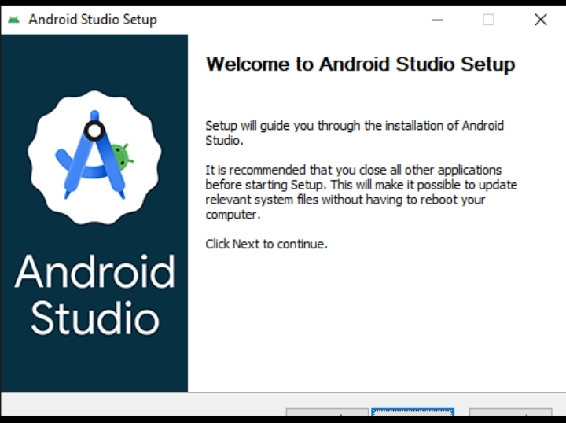
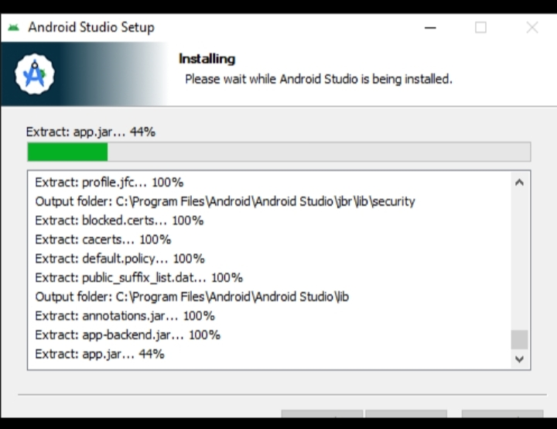
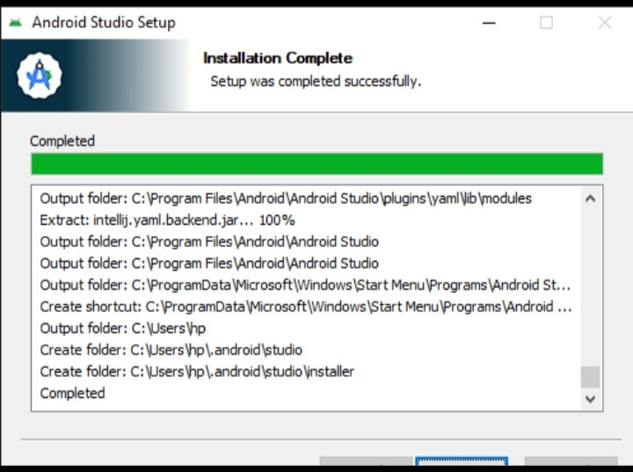
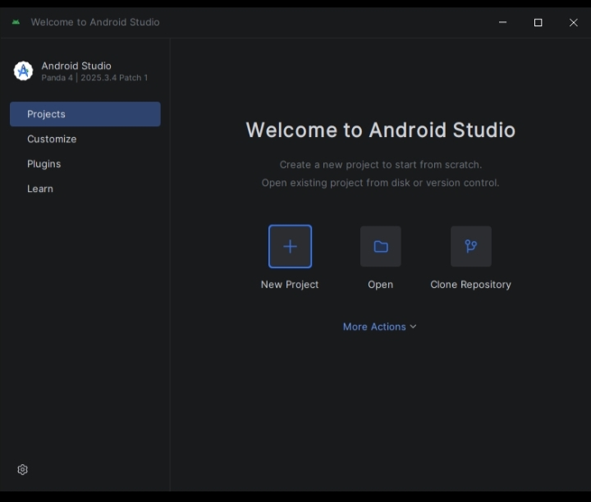

Week 1: Introduction to Mobile Application Development

Practical Activities Undertaken
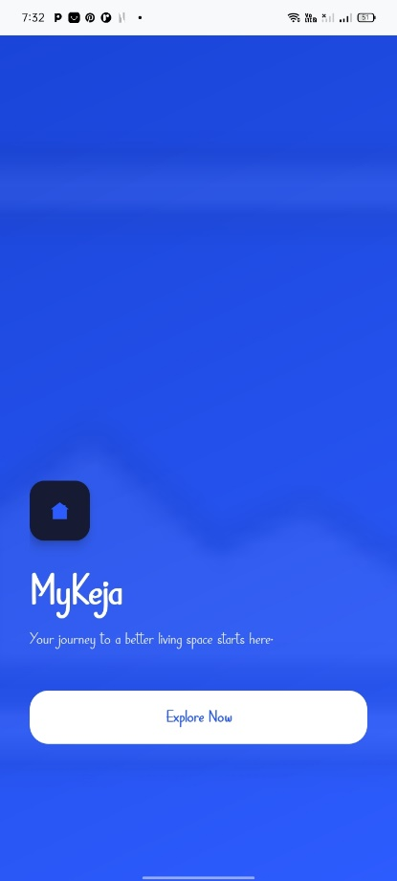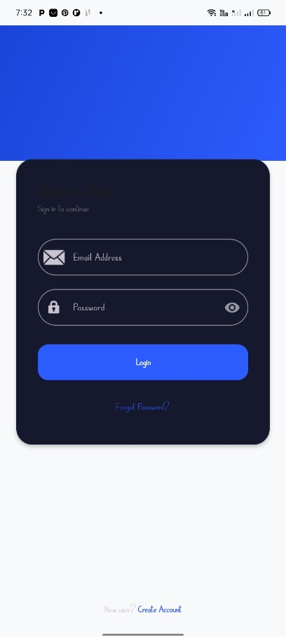
figure1.2.Splash Screen Interface: Created a figure1.2.Login Screen: created branded entry screen with the app for signing in users logo and loading bar.

Tools/Software Used
- Android Studio
- Vector Asset Studio

Personal Reflection
- This week highlighted the balance between aesthetic design and technical performance. Building the splash screen taught me that while it sets the visual identity, it must also be optimized using vector assets to prevent memory overhead. I realized that a seamless transition from the splash screen to the login interface is critical for maintaining user engagement right from the application launch

Week 2: Mobile Development Environment

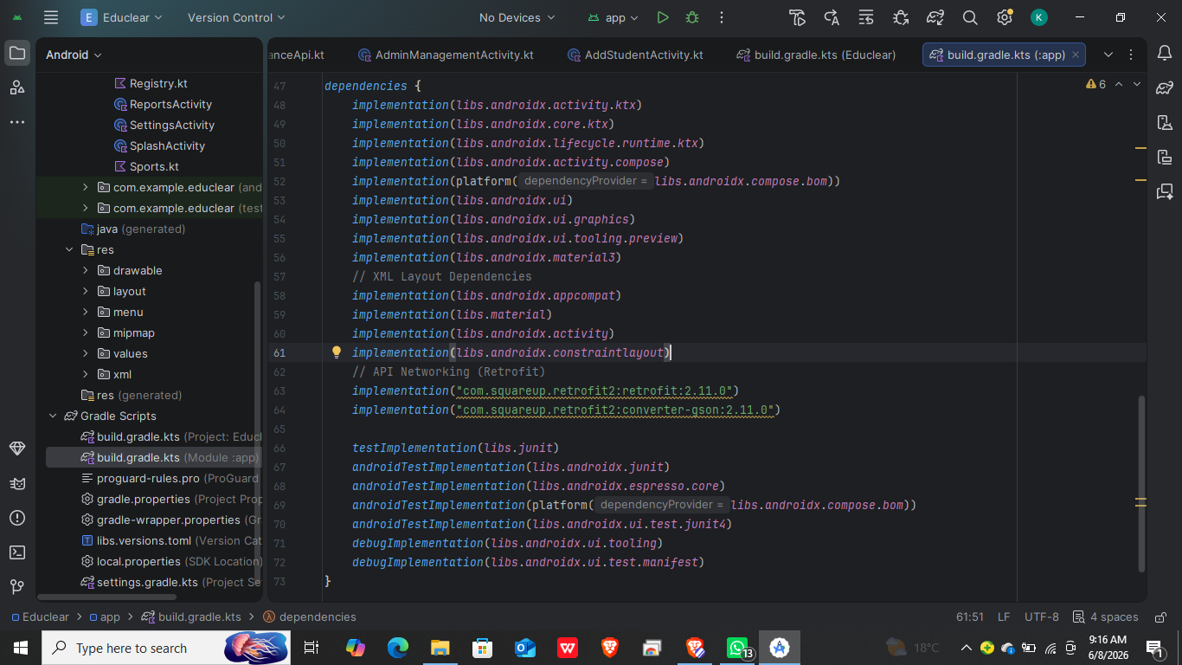
Figure 2.1. Build Configuration: Integrated Material 3 and Retrofit dependencies into the build.gradle file.

Tools/Software Used
- Android Studio
- Gradle

Personal Reflection
- This week emphasized how foundational configuration is to project scalability. Integrating external dependencies taught me to handle Gradle synchronization errors systematically. I also realized that setting up correct network permissions early is vital, as mobile operating systems enforce strict security protocols when trying to interface with local server endpoints.

Week 3: User Interface Design

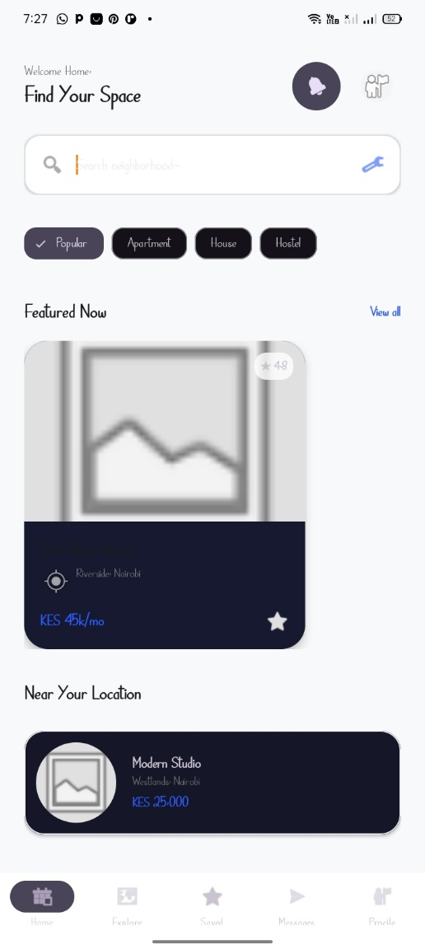
Figure 3.1. User dashboard

Tools/Software Used

Android XML

Material Design 3

Personal Reflection
- Designing the user dashboard forced me to think about UI flat-nesting and component reusability. By leveraging Material Design 3 attributes, I learned how to use unified color styles and dimensional resources to create a clean layout

Week 4: Event Handling and User Interaction

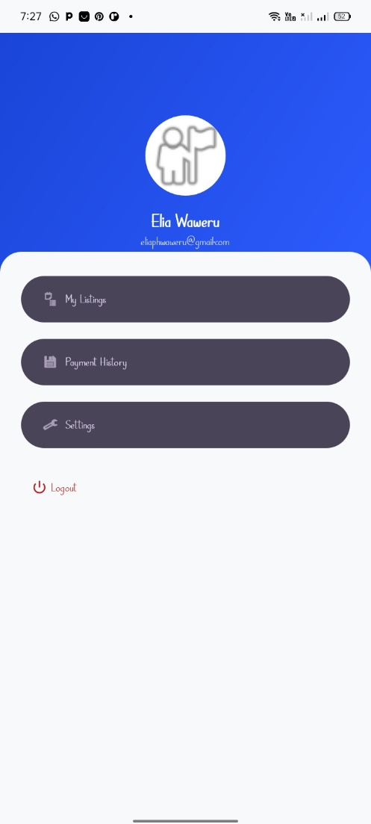

Figure4.1. Profile page

Tools/Software Used

Kotlin (onClickListener)

Activity Intents.

Personal Reflection
- I learned that handling user input requires a proactive approach to application stability. Beyond linking the login page to the profile page, I had to ensure that the application handles back-stack navigation cleanly, preventing users from accidentally navigating back to an active login screen after authentication.

Week 5: Data Management
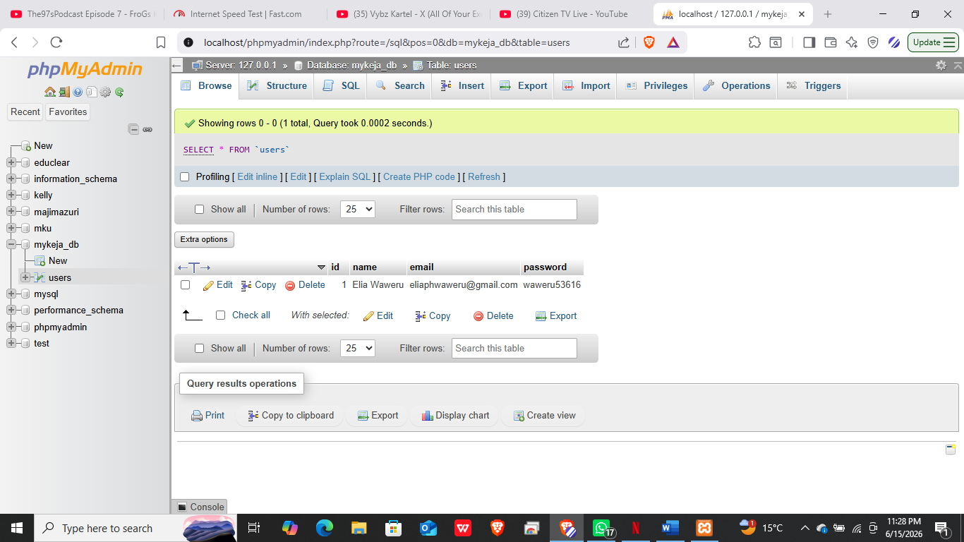figure 5.1. Created MySQL tables in XAMPP for users login

Tools/Software Used

phpMyAdmin

MySQL

GSON library.

Personal Reflection
- Designing the backend schema in phpMyAdmin taught me how crucial strict database normalization is for system performance. Mapping relational tables to handle student credentials highlighted the importance of matching data types. Using the GSON library further demonstrated how JavaScript Object Notation (JSON) bridges structured database rows with Kotlin data models.

Week 6: Networking and APIs
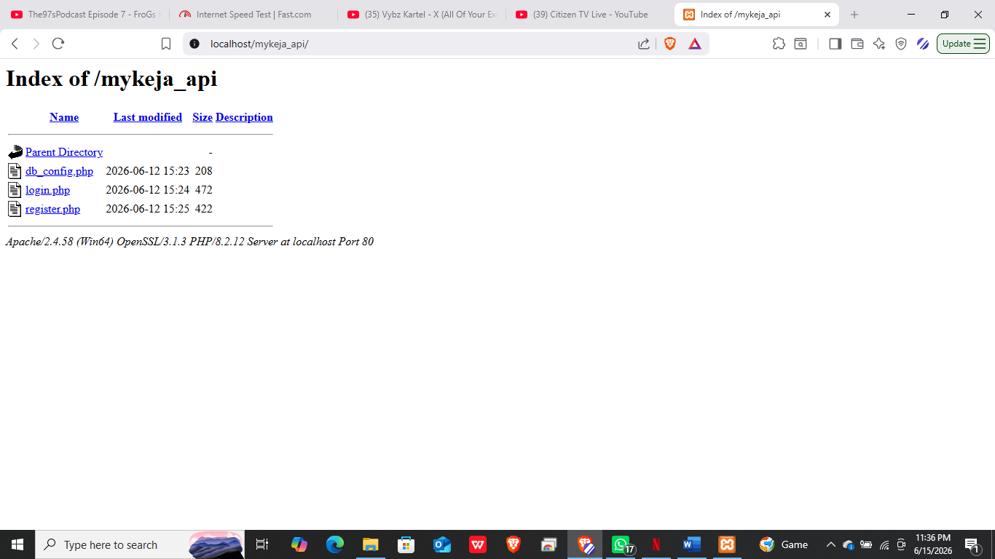figure 6.1. Wrote PHP scripts to handle logins

Tools/Software Used

Retrofit 2

PHP

XAMPP Apache

Personal Reflection
- This was the most technically demanding week, focusing heavily on client-server architecture. Implementing Retrofit interfaces taught me how to turn HTTP responses into type-safe Kotlin objects. I also gained practical experience handling runtime network exceptions, such as timeouts and connection failures, ensuring the app handles offline states cleanly without crashing.

Week 7: Application Architecture
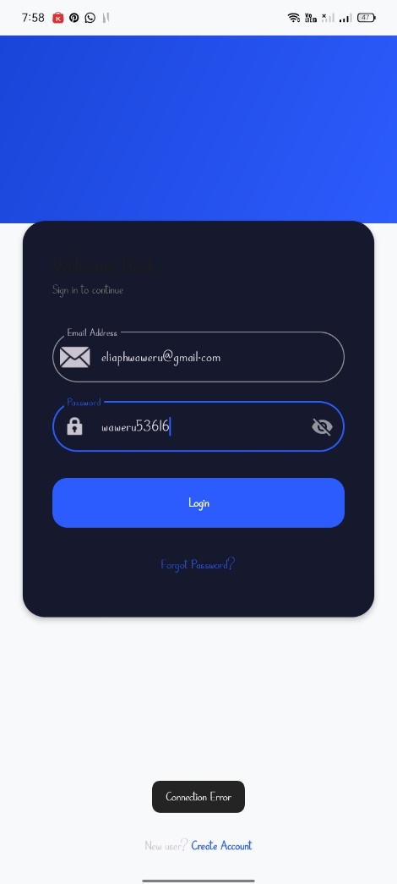
figure 7.1.Showing error of not being connected to database. Connected the app to the database server.

Tools/Software Used

PHP
- XAMPP

Personal Reflection
- This was the most technically demanding week, focusing heavily on client-server architecture. I also gained practical experience handling runtime network exceptions, such as timeouts and connection failures, ensuring the app handles offline states cleanly without crashing.

Week 8: Notifications and Background services
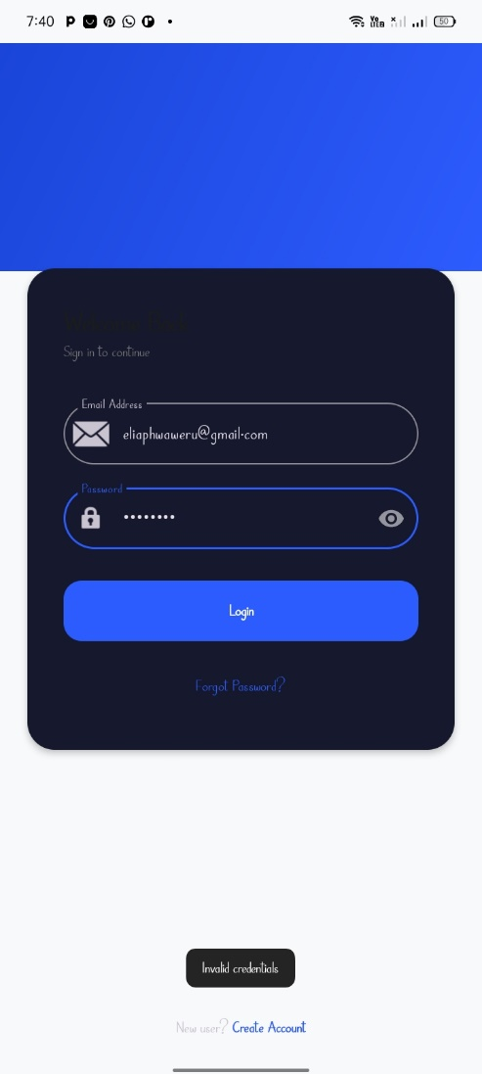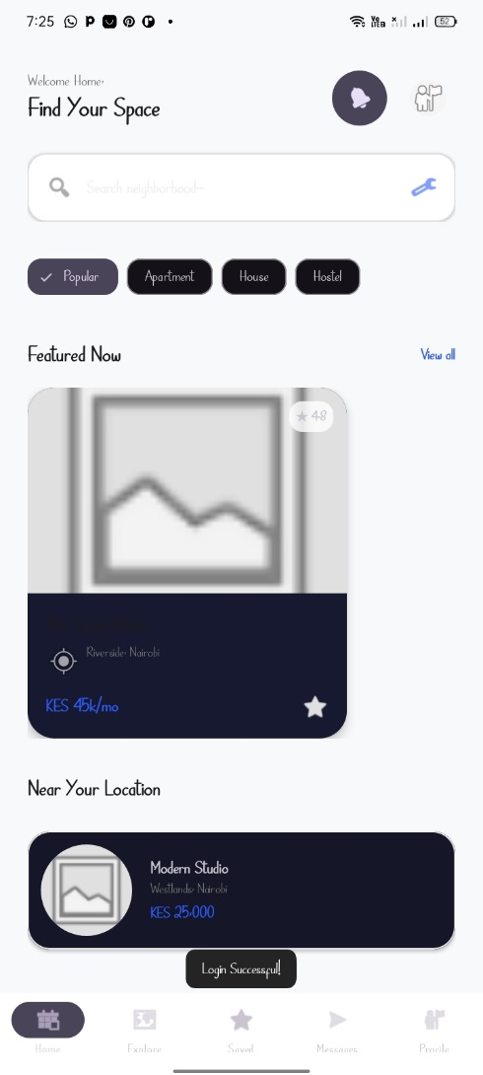
figure 8.1 and 8.2.Showing notifications after a button has been triggered

Tools/Software Used

Toast Api
- PHP

Personal Reflection
- This week I learned the importance of toast notifications that help the user to know if they are okay proceeding or incase of server error or invalid credentials.

Week 9: Device Features Integration
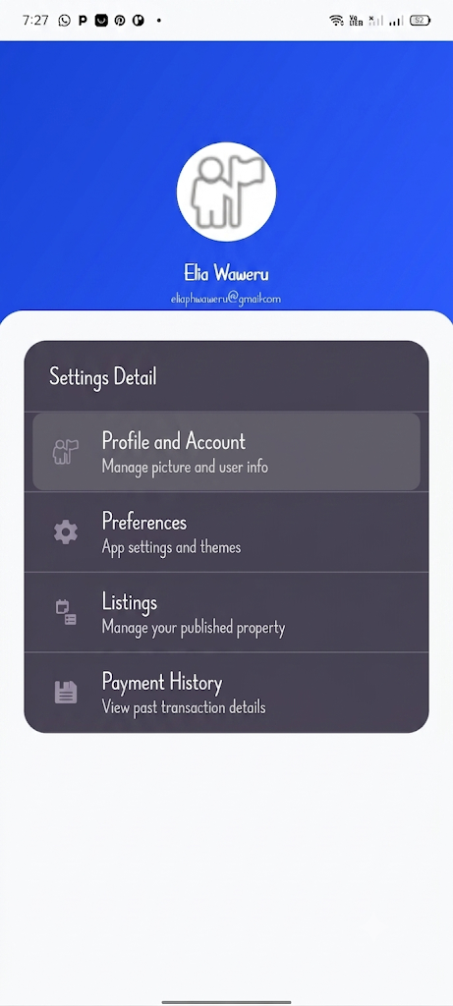
Figure 9.1.Profile screen dialog showing profile and account setting options.

Tools/Software Used
- PHP (Audit Logging)
- Android Camera API (Take Photo)
- Android Gallery/Media Picker API (Choose from Gallery)

Personal Reflection
- Implementing the Change Profile Picture feature, I learned how to request and handle device permissions for camera and storage access, and how to present these options in a simple action-sheet style modal (Take Photo, Choose from Gallery, Cancel). This reinforced the importance of designing clear, minimal UI for permission-based actions so users understand exactly what the app is requesting access to and why.

Week 10: Comprehensive Application Development, Integration and Testing.
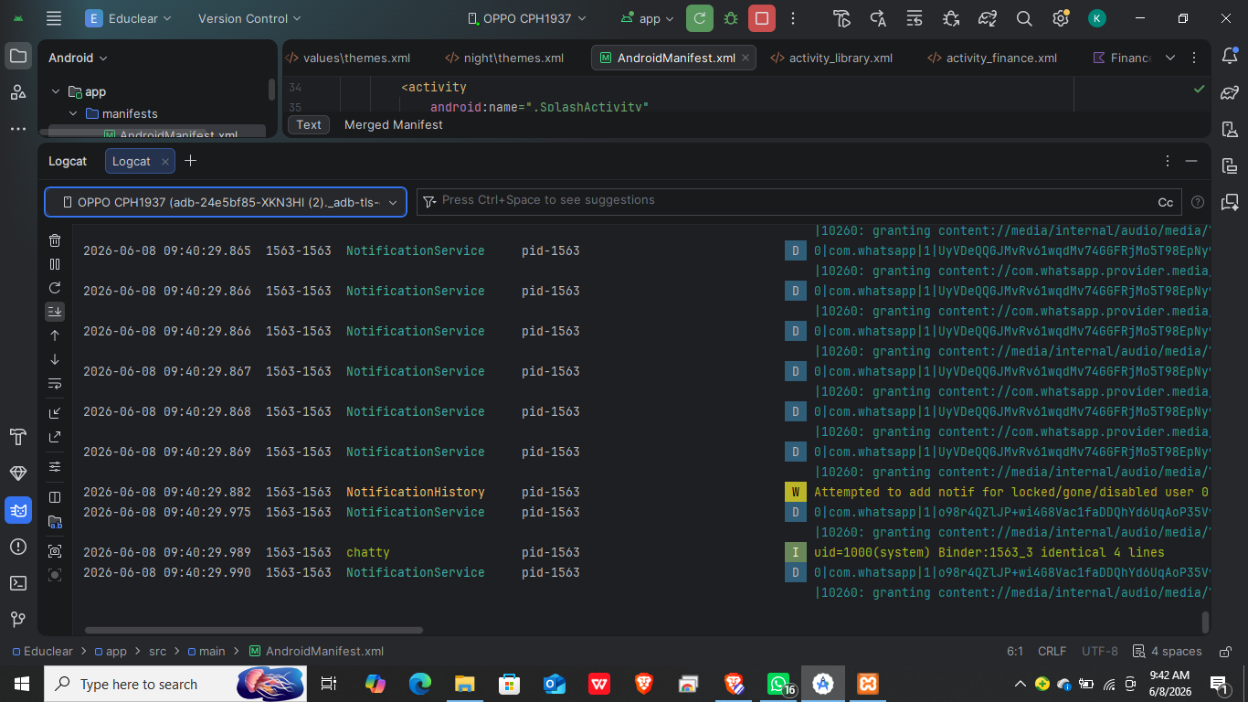
Figure 12.1. The Android Logcat window showing a "Successful Sync" successful build and installation.

Tools/Software Used

Android Logcat

Chrome DevTools (to test API responses).

Personal Reflection
- This week improved my troubleshooting skills. Fixing the theme crash taught me how Material components rely on specific parent themes to initialize UI attributes correctly.

Week 11: Application Deployment and Publishing
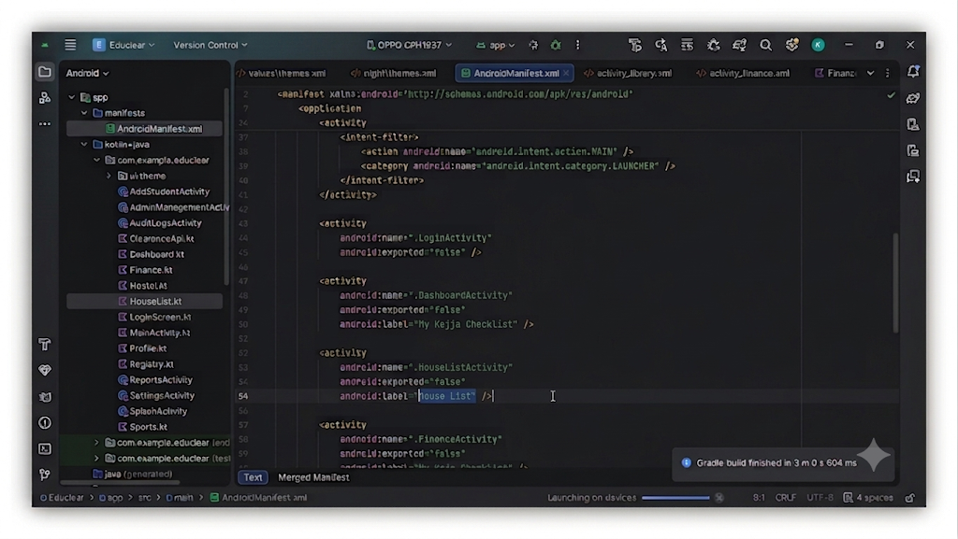
figure 11.1.Shows the AndroidManifest.xml configured with required activities and permissions prior to generating the signed release build for deployment.

Tools/Software Used

Android Manifest

Android Build Menu.

Personal Reflection

Preparing for deployment required a focus on compatibility. I learned how to optimize the app manifest to ensure the phone's hardware correctly communicates with the local XAMPP environment.

